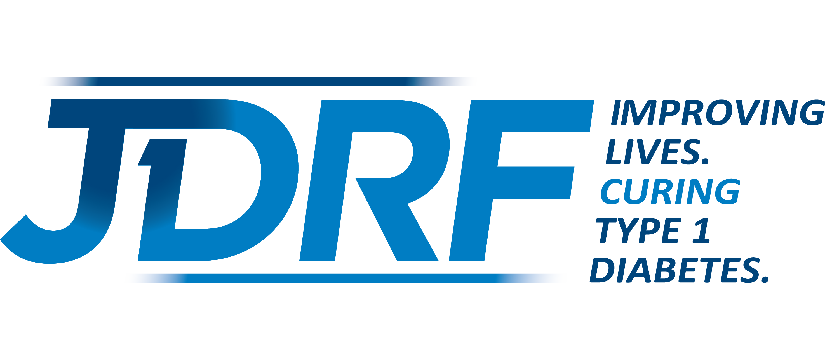

Capital Chapter Board of Directors Nomination Form
Nominations should be made confidentially; this form should be submitted by the individual making the nomination. Please complete with the information readily available to you; do not notify or request this information of the nominee. Please return via email to Cathy Chisholm at cchisholm@jdrf.org.

First/Last Name:
Primary Contact Number: Email Address:
Please indicate work/home/cell

Employer: Title/Occupation:

T1D Connection:
If applicable

Brief summary of candidate’s Professional Successes, Community Involvement, Leadership,
Fundraising and Non-Profit Experience:

Does the candidate exemplify the Qualities of High Impact JDRF Boards as outlined below?

Mission-Oriented: Will they advocate for JDRF by serving as an ambassador of its mission in the
community? Yes or No
Fundraising-Focused: Will they be supportive of the critical role of the board in fundraising, both
through personal giving and leveraging their personal/professional network? Yes or No
Collaborative and Respectful: Will their contributions serve to strengthen the team environment
with a high-level of individual accountability? Yes or No
Engaged and Motivated: Does the candidate have the availability to actively participate in the work
of the Board? Yes or No

Additional ways the candidate will focus their time, talent and treasure to make a substantial and meaningful impact on JDRF’s mission?

Completed By:

Name:

