Walk Participant Guide

Table of Contents
Welcome 3
Contact Us 3
Why We Walk 4
Celebrate Your Loved Ones 4
Help Change Lives 4
Contribute to a Cure 4
Find Your Community 4
Walk Day: What to Expect 6
Event Details 6
Event Schedule 6
Event Overview 6
Getting Started: Build Your Team 7
Getting Started: Fundraising 9
Maximize Your Fundraising 10
Breakthrough T1D Walk App 10
Create a Facebook Fundraiser 10
Bonfire 11
Engage Your Employer! 11
Fundraising Incentives 12
T-shirt 12
New this year: V1P Club! 12
New post-event prizes! 12
Frequently Asked Questions 13

Welcome
We are so glad you decided to join us for the Breakthrough T1DTM Walk. Participating in the Breakthrough T1D Walk is a great way to show the world that together, we can conquer type 1 diabetes (T1D). Building a team is fun and empowers you to raise even more funds to support Breakthrough T1D in accelerating T1D breakthroughs. Now you are part of the largest T1D event in the world, no matter where you are. Breakthrough T1D Walk is an opportunity to build community, develop leadership skills, promote health and wellness, and bring together friends and family to support an important cause.

We welcome you to invite as many people as possible to join in the celebration–friends, family, neighbors, and colleagues call all be part of the team! Building a team is not just more fun but will allow you to raise even more funds to support us in accelerating breakthroughs. With your help, the Breakthrough T1D Walk will power more research, enable more advocacy, and fund more support for everyone living with T1D. You are part of the lasting footprint we'll make for the T1D community now, and for generations to come.

Contact Us
Ashleigh Sand
Development Manager
asand@breakthrought1d.org
920.243.7504 o| 219.689.3538 c|

Why We Walk
At Breakthrough T1D Walk, we work tirelessly to accelerate breakthroughs to cure type 1 diabetes (T1D) and improve the lives of those living with the disease. We continually expand our scientific knowledge, our connections and condition, our partners and our global presence to unlock the science that will stop T1D. While we fight for cures, together with you, we strive just as hard to develop therapies to help people right now. Breakthrough T1D and our team of scientists are leading T1D research around the world. No organization is making a bigger impact on advances in this field.
 |  |  | 
Celebrate Your Loved Ones | Help  Change Lives | Contribute  to a Cure | Find Your Community
Together, we walk to support the millions of people living with T1D. Whether you have a direct connection to the disease or not, everyone is invited to make a difference as we celebrate our loved ones  with T1D. | Each year, an estimated 64,000 people in the U.S. are diagnosed with T1D. And, less than one third of those living with T1D are achieving target blood glucose levels —putting them at risk for complications. Let's bring that number to zero. | If you want to help put an end to T1D, this is your opportunity. By joining Breakthrough T1D Walk,  you'll support breakthroughs that get us closer to cures —and provide hope to the millions affected by this disease. | We're a community that's committed to doing whatever it takes to put an end to T1D. When you join Breakthrough T1D Walk, you can meet others who have been through similar experiences and find resources, support, and connection.

The steps we take in Walk pave the way for breakthroughs in Breakthrough T1D-funded research, advocacy, and support of the T1D community.
 | 400+ active projects funded  around the globe today | 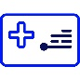 | All 25 of the U.S.'s largest private health insurers offer coverage of automated insulin delivery (AID) systems for people living with T1D
 | Over $2.5 billion committed in research grants since our founding  in 1970 |  | 30,000+ people have joined Breakthrough T1D Community Forum's vibrant social network  for the T1D community
 | 59+ Breakthrough-T1D funded clinical trials currently under way |  | Nearly 20,000 care kits delivered annually to newly diagnosed families
 | Nearly $3.5 billion secured in federal funding through the Special Diabetes Program since it began 25+ years ago |  | 1 million+ adults and children with T1D have joined our events to fundraise for T1D research
 | Approximately 500 meetings with Members of Congress and their staff each year

Walk Day: What to Expect
Walk day is all about celebrating our T1D champions–here's what you need to know to make the most of the day for the T1D in your life!

Event Details:
May 17, 2025
Activities start at 8:30 a.m.| Actual Walk Begins at 10 a.m.|
Riverside Park
500 E. Wisconsin Ave. Neenah, WI 54956
Length of Course: 2 miles

Event Schedule:
8:30 AM- Activities Open, Vendors Available
9:30 AM- T1D Parade Staging Begins
9:40 AM- T1D Parade and All T1D Photo, Opening Ceremonies
10:00 AM- Walk Starts
11:00 AM- T-shirt Showcase
11:15 AM- Games with Prizes, Fundraising Awards
11:45 AM- Preliminary Totals Announced
12:00 PM- Activities Conclude

Event Overview:
Once you arrive, feel free to explore the site and check everything out! There is time for teams to get settled, explore the Walk site and talk to vendors before starting the Walk. If you're living with T1D, be sure to grab your T1D identifier to show the work that you’re a champion! We will kick off the event with some short announcements, our T1D Champion parade*, and then we'll be off to the Walk route. When teams return there will be activities and entertainment for walkers of all ages to keep the party going, so be sure to stick around.
T1D Champion Parade. As part of the opening ceremony, we will gather ALL our T1D champions together to parade through the site. We will honor all T1D Champions by how many years they've been a T1D warrior and cheer them on. Please plan for extra time on Walk Day to make sure your champion is there to get lined up with the help of our volunteers. There will also be time after the parade for T1D champions to make it back to their teams before the official start to ensure all families are able to walk the route together.

Getting Started: Build Your Team
Make your Walk Day more exciting by inviting your network to join your team! Rally your friends, family, neighbors, and colleagues to join you in advancing breakthroughs in T1D research. Together we can make the biggest impact possible! The most successful teams lock arms with their network. We encourage you to strive for having 10 or more members who are all working together to raise life-changing funds for Breakthrough T1D's mission. All team members must be registered
to attend Walk Day.
Consider your sphere of influence. Who do you interact with regularly? Ask them to be a part
of your mission to advance breakthroughs. Using the guide below, write down the names of
people you know from each category for a quick list of people you can ask to join your team
and/or donate!
Friends & Family: Parents, siblings, in-laws, cousins, grandparents, friends
Employer: Co-workers, clients, vendors, other departments or branches
Community: Neighbors, HOA, civic clubs, networking groups
Activities: Gym, book club, sports, places of worship, alumni groups
Schools: PTA, teachers, classmates, alumni, children’s parents, Greek life
Businesses you frequent: Salon, doctor (ex. endocrinologist, general physician, etc.),
mechanic, restaurants, dry cleaner, dentist, maintenance, cleaning
Once your list is compiled, it is time to start building your team! Keep your list with you, you might think of more individuals to add to your list while you’re in your daily routine.
Set up your team webpage. Visit your participant center to build your team page. Include photos and tell your story.
Set a team goal. Determine a goal for the size of your team and the amount of funds you wish to raise. We recommend a goal of at least ten teammates, raising $100 each. Your local Breakthrough T1D staff can also work with you to help determine your team goal AND a fundraising plan to help you be successful in achieving your goal.
Recruit your network. Send emails, texts and post on social media to invite others to be a part of the team. You’ll find recruitment email templates in the participant center that you
can use. Ask people from across the country to join your team, even if they cannot make
it in person.
Follow up. It can take several asks for someone to take action. Make sure all teammates are registered online to ensure they have access to our exciting incentive program and information about Walk day.
Cheer on your team. Work with your team members to set personal fundraising goals. Consider a group fundraiser in addition to supporting their efforts and motivating them to reach fundraising milestones. Share strategies that have made you successful and pass along reminders from your staff partner.

Getting Started: Fundraising
Fundraising for Breakthrough T1D is easy, fun, and rewarding. We provide you with support every step of the way to ask your family, friends, neighbors, and coworkers to donate and join Breakthrough T1D and help create a world without type 1 diabetes (T1D).
Set a goal. A goal can keep you motivated by tracking your progress with each donation, and people will want to help you reach it.
Use numbers that are important to you and your T1D story, such as the date you were diagnosed, your age, or how many days you have lived with T1D. Example: Since diagnosis, Owen has lived with T1D for 4,203 days, so my team will walk 4,203 miles and raise $4,203 to drive awareness and fund research for a cure!
Your local Breakthrough T1D staff can help you determine a goal for your team. Think of them as your team's coach there to cheer you on to fundraising success each step of the way.
Make a personal donation. Start off strong! By making a personal gift you set a positive example and show how dedicated you are to creating a world without T1D. Then, challenge your community to match your donation!
Personalize your page. Share your story with your community! Inspire your friends and family by adding your photos and telling your story of why raising money for T1D research means so much to you. Don’t forget to add a personal short link to your webpage to make it easier to remember as well!
Download the new Breakthrough T1D Walk app. The app gives you the opportunity to personalize your fundraising experience further. Add stickers and additional photos; leverage technology to spread the word and easily ask for support across various platforms; deposit check donations; and track your progress!
Make your contact list. Think about all the people who will appreciate your story. Remember the larger the list you start with, the better your results will be. Gather names from your email account, address book, holiday cards list, and social networking sites.
Then think about the people you interact with every day, people from your past, people at your local businesses and those extra-special people in your life to make sure you don’t
miss anyone.
Share your story. Use your favorite way–social media, email, texting, in person, or through the mobile app to share how type 1 diabetes has impacted your life or the life of someone you love. If you’re not sure what to say, the participant center provides sample messages and social graphics to use! It is important to be specific about how you would like each person to support you–share your goal and give suggested donation amounts or ask them to join your team to fundraise too!
Follow up. Just like you, your friends and family are busy and it may take a friendly reminder, or two, before they make a donation. Don’t get discouraged if people don’t donate right away. We recommend a minimum of three outreaches to your network.
Thank your donors. Saying ‘thank you!’ to those who donated is important to being a successful fundraiser. Plus, when people feel appreciated, they are more likely to donate to your next fundraiser too!

Maximize Your Fundraising

Breakthrough T1D Walk App
Using the NEW Breakthrough T1D Walk app is a powerful way to raise more funds for critical T1D research and reach your goals faster. You can fundraise from the palm of your hand. Search for the app in your Apple App Store or Google Play Store.
- Personalize your page from the app. With the ability to add some fun stickers to photos before uploading them to your fundraising page.
- Earn Badges.
- Mobile Check Deposit—for those check donations you may receive from your
fundraising asks.
- Access a Personal QR Code
- Use Snapchat, WhatsApp, LinkedIn and Text messaging to ask for donations through the
mobile app.

Create a Facebook Fundraiser
Expand your reach and grow your impact by connecting your Walk page with Facebook. On average, fundraisers who use the Facebook app raise 3x more than those who don't. Make sure you personalize your fundraising page before linking to Facebook.
- Connect your Breakthrough T1D page to Facebook through your participant center or directly through the Breakthrough T1D Walk App. Please note that this must be created through your participant center to ensure that fundraising dollars are credited to your personal
fundraising page.
- Invite friends, share updates and collect donations through your Facebook fundraising page.
- The money you raise on Facebook will count toward your Breakthrough T1D fundraiser.

Bonfire
Breakthrough T1D Walk has partnered with Bonfire to provide you with this free and simple-to-use fundraising tool! Create your own unique design or use one of our handy templates. Every shirt sold will be printed, shipped and delivered to your supporters for you. On top of that, 100% of the proceeds raised will be sent to Breakthrough T1D and help to boost your fundraising thermometer. To create a t-shirt fundraiser, look for the Bonfire banner in your participant center.
No inventory–All proceeds go to Breakthrough T1D.
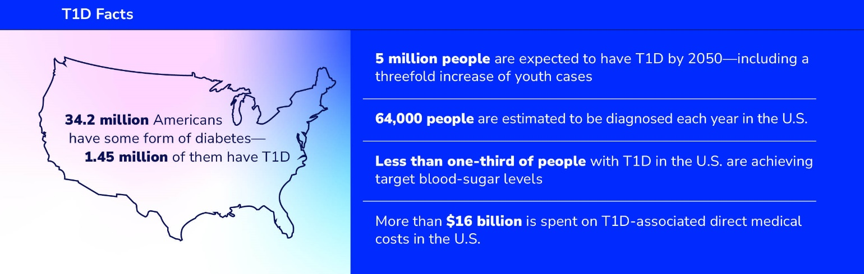

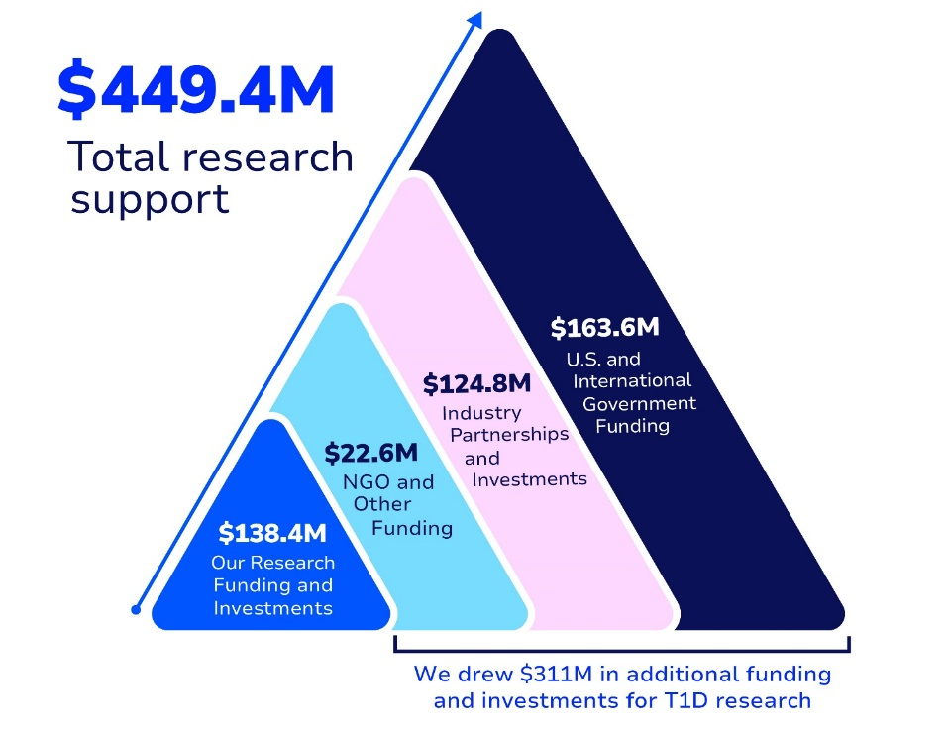

Fundraising Incentives
Every dollar matters in the fight against type 1 diabetes. You are changing the future for people living with T1D. Because of your fundraising efforts, you have a chance to earn exciting prizes and take advantage of exclusive opportunities!

T-shirt
Earn your official Breakthrough T1D Walk participant shirt when you raise $100. Once you’ve hit this milestone, your t-shirt will be mailed directly to the address listed at registration.

Mile of Hope:
When your TEAM raises $1,000+ you earn a Mile of Hope Sign. The Mile of Hope is the last stretch of the walk where we honor our T1Ds with a special sign. You can customize your yard sign to be a personal message, thank you to supporters, or even something funny! The best part is you get to take the sign with you!

Team Tent:
When your TEAM raises $5,000+ you are officially part of the Team Village. Your team will receive a private 10x10 pop up tent. This is a great gathering spot on Walk Day.

New this year: V1P Club!
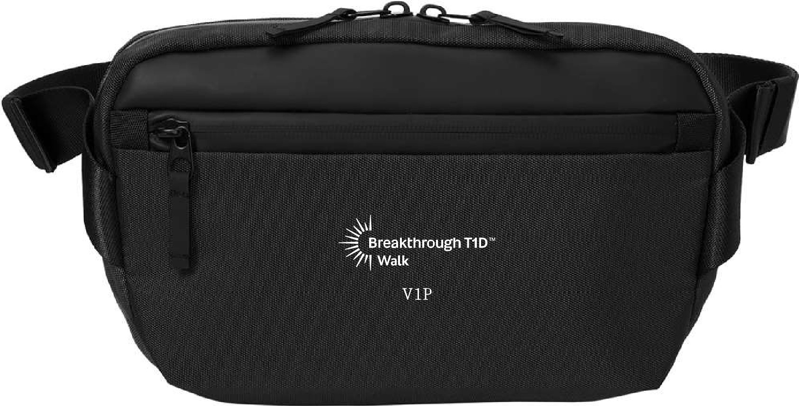
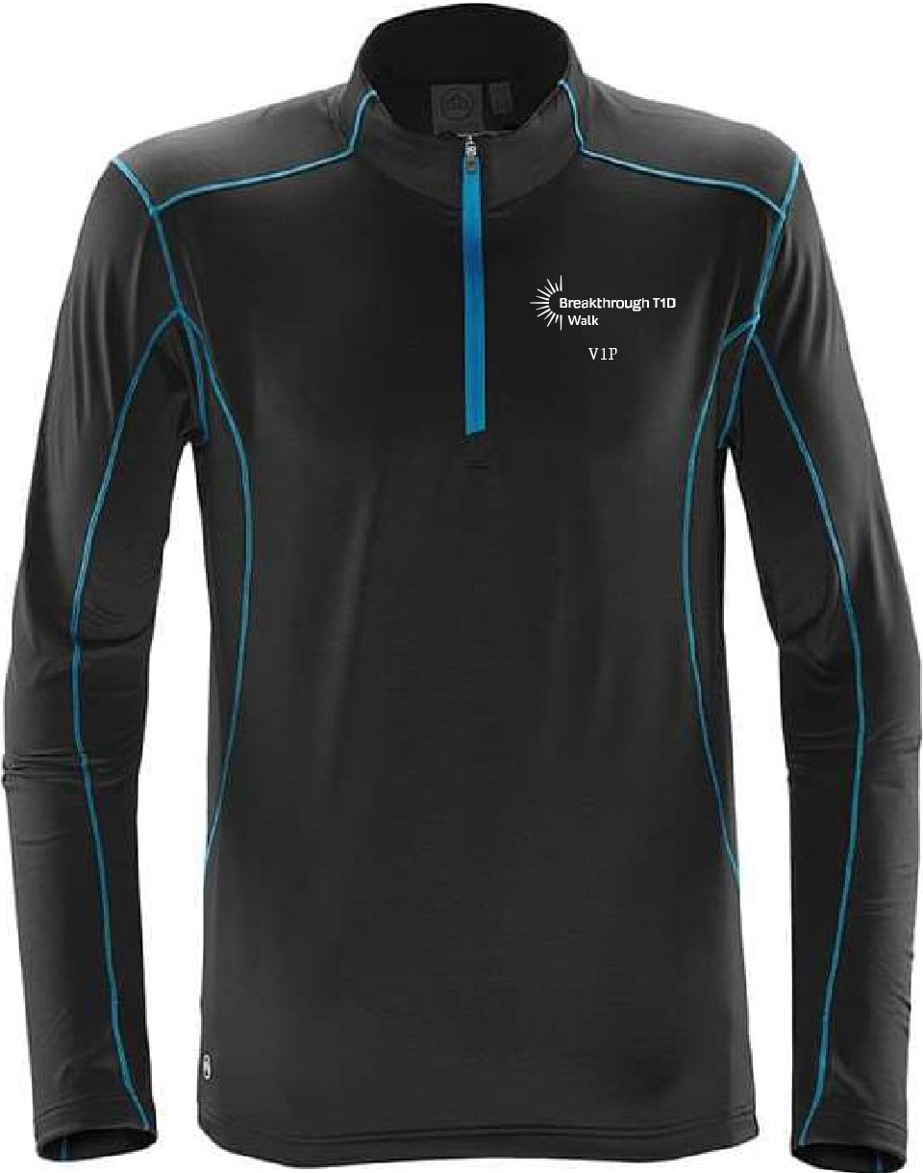
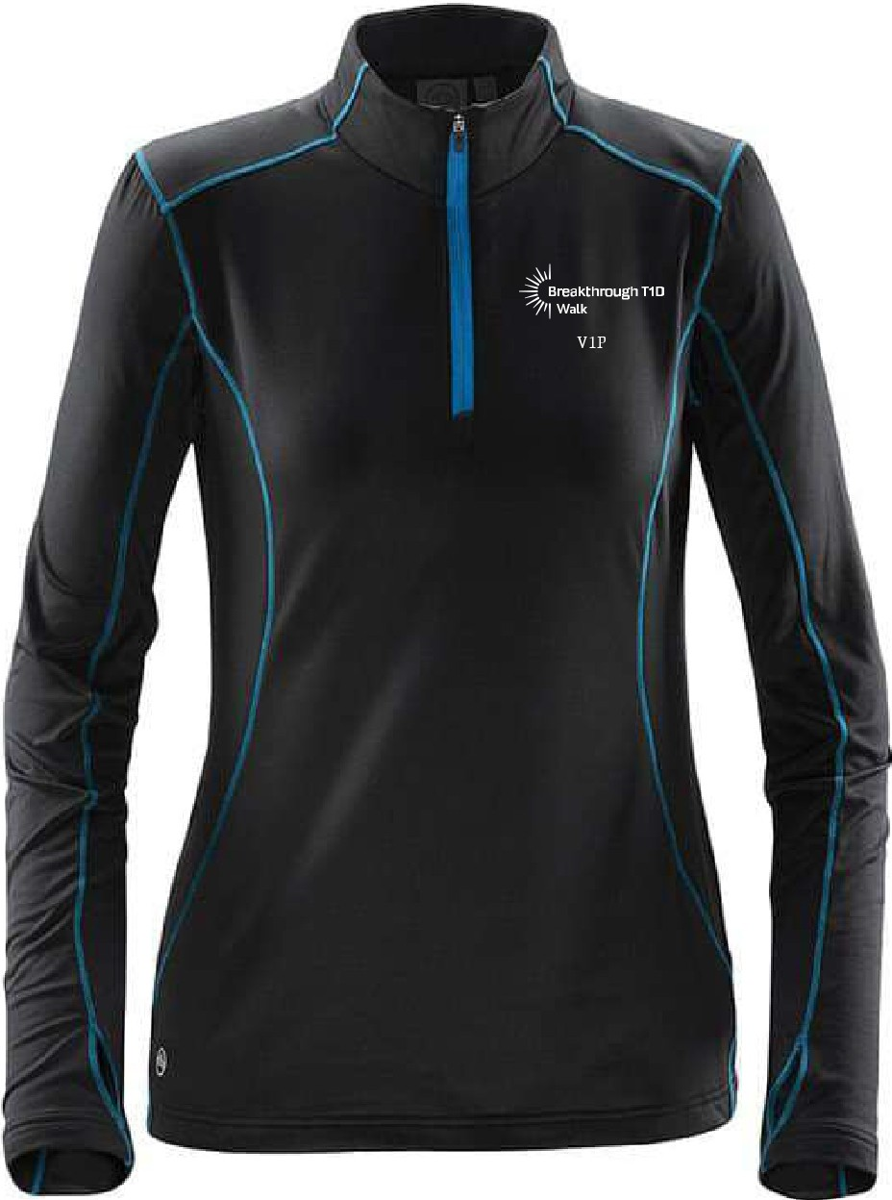
Receive exclusive V1P Club items shipped directly to you when you hit the $500 and $1,000 fundraising milestones. Plus, you’ll receive additional event day perks when you achieve $1,000.

New post-event prizes!
You’ll be eligible for post-event prizes at $250, $500, $750, $1,000, $2,500, $5,000, and $10,000 levels. Be on the lookout ten days after your event for your prize catalog email!
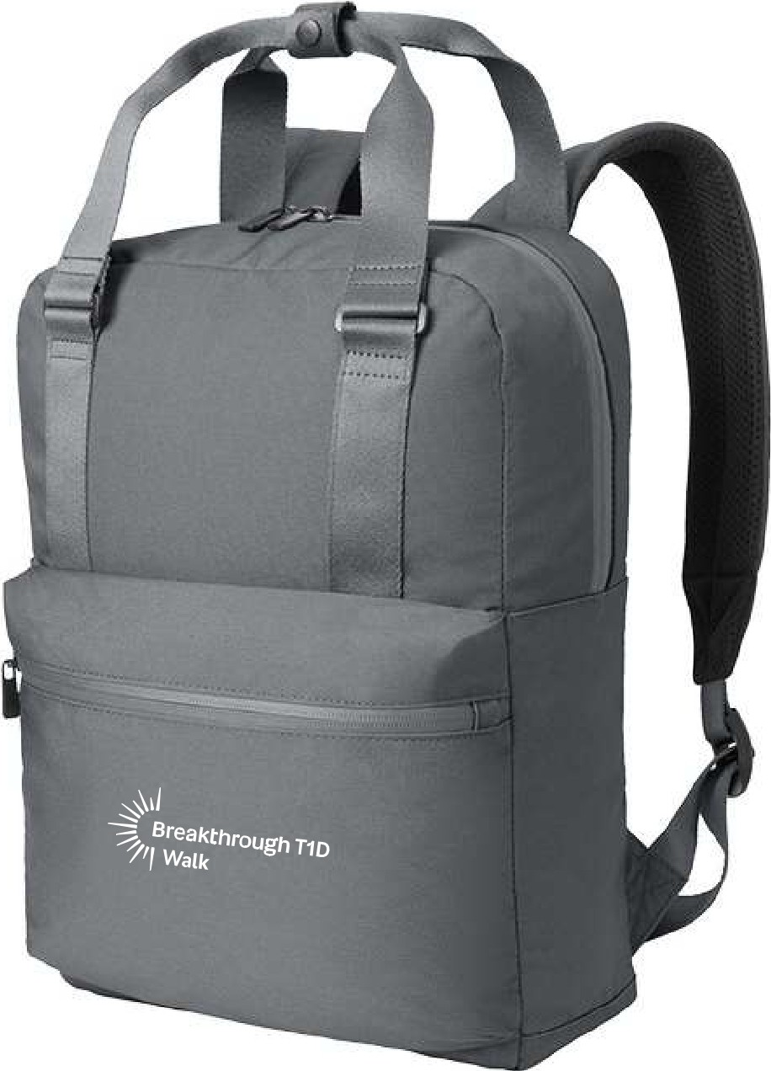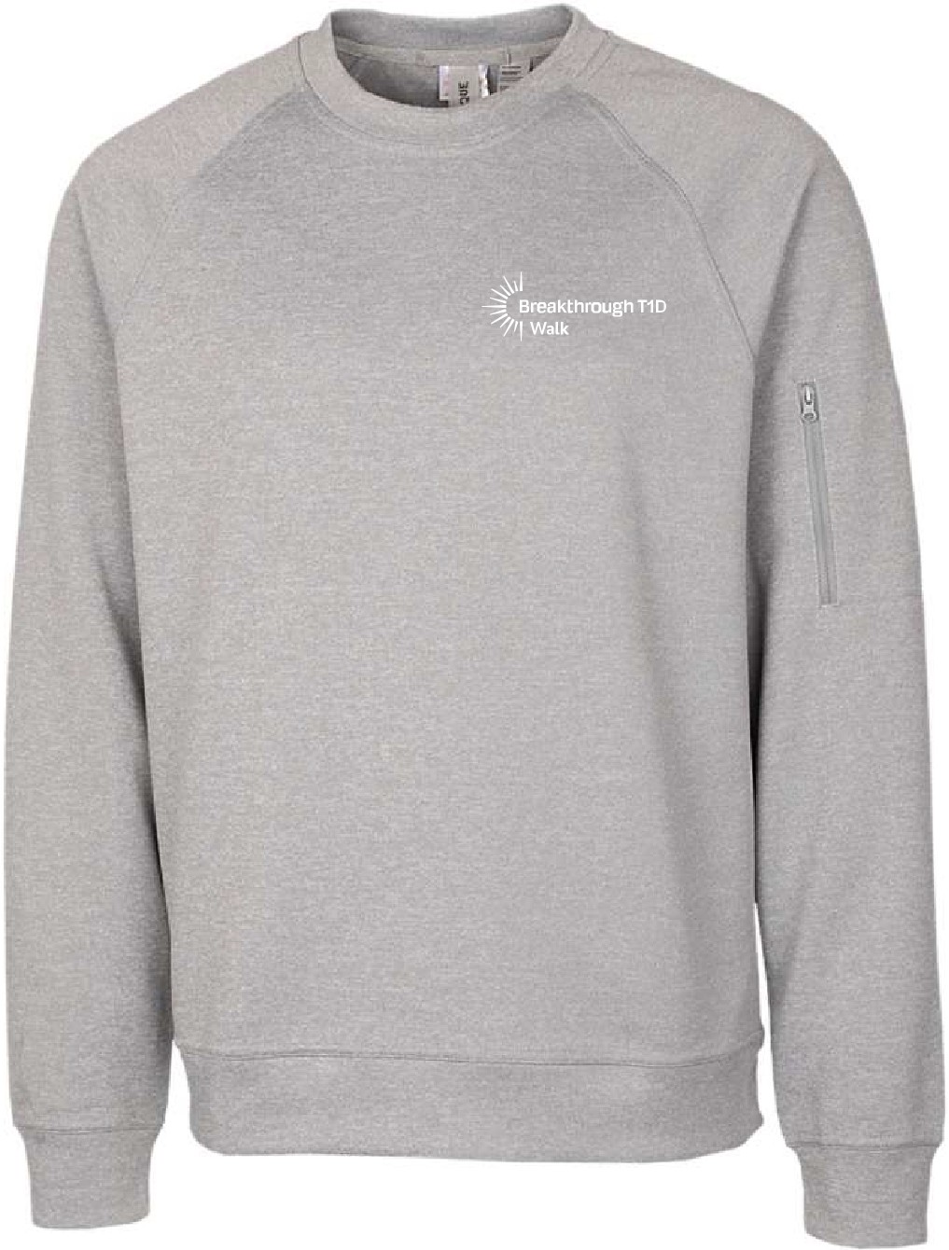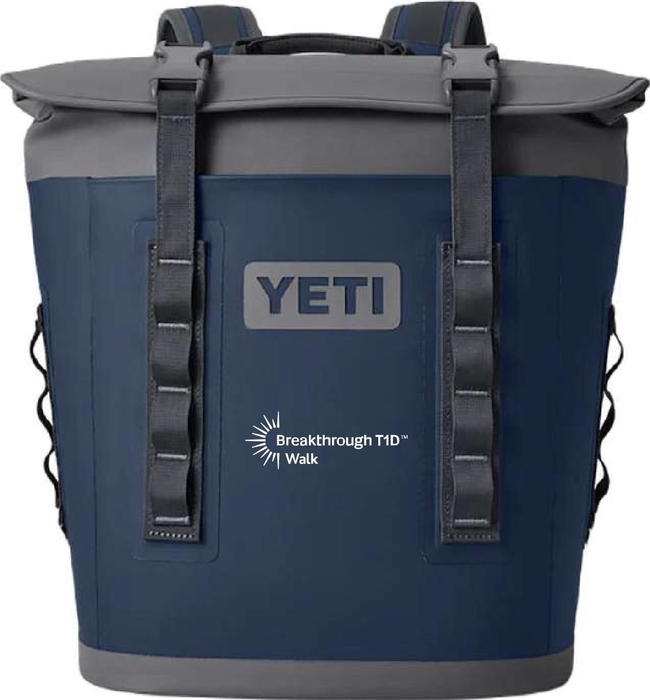

Frequently Asked Questions
Is there a fundraising minimum? Nope! You can create a team and set a fundraising goal that you are comfortable with. Our staff and volunteers are here to help you reach your goals, no matter what level you set. Whether you raise $10 or $1,000, every dollar raised through Breakthrough T1D Walk brings us closer to cures and we can’t wait to announce the total our teams have raised on Walk Day. While there is no fundraising minimum, walkers who raise $100 or more will receive the official (and collectable) Walk t-shirt.
Do I need to register my child/children for the walk? All participants must register and complete the online waiver. Please plan to register your child/children at the time of an adult registration.
How do I earn a t-shirt? Register for Walk and raise or donate $100 as an individual.
Once you have raised $100, your t-shirt will be mailed directly to the address used at registration.
What if I have donations on Walk Day? We strongly encourage all donations to be turned in before Walk Day to ensure you get as many Breakthrough T1D Walk incentives as possible, including the NEW pre-event redemption items. Plus, you don’t have to worry about carrying cash or checks around. We will have QR codes throughout the walk site for anyone wanting to make an online donation on Walk Day too! The NEW Breakthrough T1D Walk App provides the opportunity for mobile check deposit.
If you do have donations, please stop at the Breakthrough T1D Info Tent at the entrance of the Walk site and a volunteer will help collect those donations.
What if it rains on Walk Day? Walk is a rain or shine event, so come prepared for whatever weather is scheduled. We will do our best to monitor any severe situations should they arise.
What do I wear? Walkers will often wear jeans, athleisure wear, sneakers (or boots), sweatshirts/jackets and t-shirts! Often, team captains will create t-shirts for the whole group to wear! This makes your team easily identifiable to each other and sparks comradery. Otherwise, we recommend wearing your official Breakthrough T1D Walk t-shirt (see prizes and incentives)!
Are there emergency services on site? Yes! We have a first-aid tent and EMTs on site to assist in the case of any emergency.

What is there to do at the Walk? We have lots of exciting things happening on Walk day!
There will be games and entertainment, as well as the opportunity to visit vendor booths, our Mission/Advocacy tent, Activity Zone, V1P area, food, and more! Walk Day is one big celebration of all your accomplishments, and it is a great time to meet your local T1D community and make new friends! If this is your first Breakthrough T1D Walk, don’t miss visiting Resource Row!
How will I turn in my cash & check donations? If you have checks, we encourage you to use the NEW Breakthrough T1D Walk app to utilize the mobile check deposit feature. Utilizing this feature will allow you to immediately see your thermometer rise and earn pre-walk day incentives. If you are unable to use the mobile app feature, you can mail them to the Breakthrough T1D processing center at PO Box 5064 Hagerstown, MD 21741-5006. Please include a note with your team’s name, and what participant to credit the donation to (if applicable). If you have cash, we suggest you convert it to a check and mail it to the office, or make an online donation.
Where do I park?
$1,000 V1Ps will be given a parking pass to park in reserved parking next to the park. Otherwise street parking is available.
Are dogs allowed?
Yes, dogs are allowed, but we ask you please keep them on a leash and clean up after them.

