Northern California Clinical Trials
DRUG | FABULINUS  AGES 12-21  WITHIN 3 MONTHS OF DIAGNOSIS INFUSION FOLLOWED BY INJECTIONS  SAN FRANCISCO (UCSF MISSION BAY) | 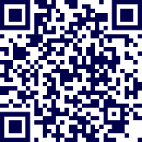
DRUG | CNP-103  AGES 12-35  DIAGNOSED FOR LESS THAN 6 MONTHS  IV INFUSIONS  WALNUT CREEK (DIABLO CLINICAL RESEARCH) | 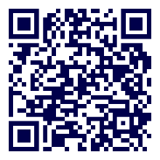
  Cell Therapy | A Safety, Tolerability, and Efficacy Study of VX-880 in Participants w/Type 1 Diabetes  PARTICIPANTS: AGES 18-65  w/SEVERE HYPOGLYCEMIA  T1D AT LEAST 5 YEARS  SAN FRANCISCO (UCSF) | 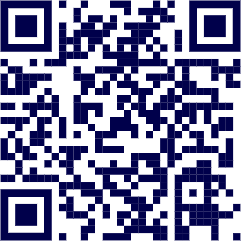

  OBSERVATIONAL | COSCLIP  AGES 18+,  DX T1D PRIOR TO PREGNANCY,  ACTIVE USE OF AID  SAN FRANCISCO (UCSF) | 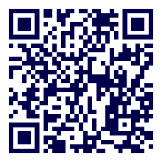
OBSERVATIONAL | HLA DEMOGRAPHICS STUDY IN ADULTS WITH TYPE 1 DIABETES  AGES 18-45  WITHIN 2 MONTHS OF DIAGNOSIS  BLOOD DRAW  SAN FRANCISCO (UCSF) | 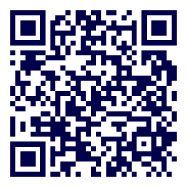
  BEHAVIORAL | DREAM  AGES 13-17,  IDENTIFY AS LATINA/O/X or OTHER VARIATIONS SUCH AS HISPANIC  RECEIVES DIABETES CARE AT UCSF,  VIRTUAL PEER GROUPS | 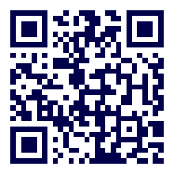
BEHAVIORAL | TELEHEALTH SUPPORT FOR TYPE 1 DIABETES  AGES 5-18,  T1D AT LEAST 1 YEAR  RECEIVES DIABETES CARE AT UCD PEDIATRICS DIABETES CLINIC  SACRAMENTO  (UNIVERSITY OF CALIFORNIA -DAVIS) | 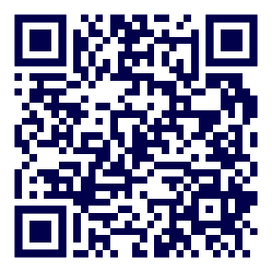
DRUG | SUGARNSALT  AGES 18-75,  T1D AT LEAST 8 YEARS  A1c LESS THAN 10%  EXPERIENCING KIDNEY PROBLEMS  OR PROTEIN IN URINE  STANFORD | 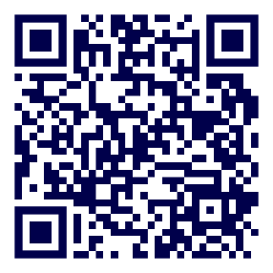
OBSERVATIONAL | BETA  AGES 18+,  ESTABLISHED T1D DIAGNOSIS  A1c LESS THAN 8%  BMI BETWEEN 18-40 kg/m²  NOVATO | 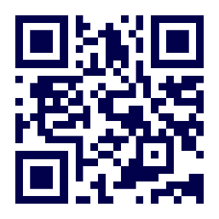
  DEVICE | DEVICE USABILITY STUDY  AGES 15+  SUNNYVALE | 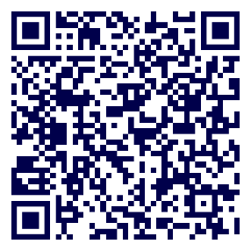

Trial Tools & Contact Information
  TRIAL TOOLS | Clinical Trials Connection Tool  Match To A Clinical Trial In 60 Seconds | 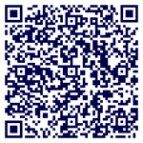
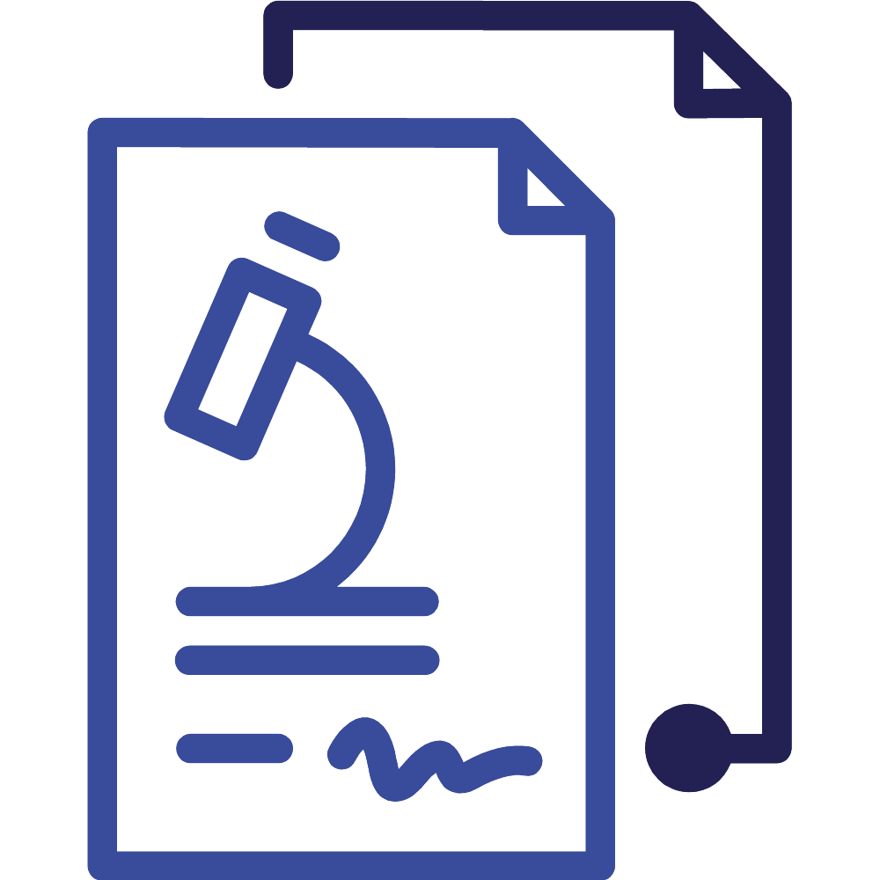  WEBSITE | Learn More About Clinical Trials | 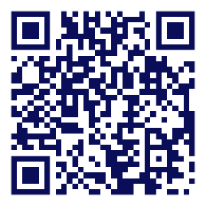
  CONTACT INFO | Breakthrough T1D Northern California  Clinical Trial Education Volunteers  Kim Fisher: kimfisherschwab@gmail.com  Joe Carlino: carlino1@earthlink.net  Vanessa Larco: vanessa.larco@gmail.com  Kirin Jamison: kirinj@gmail.com | 