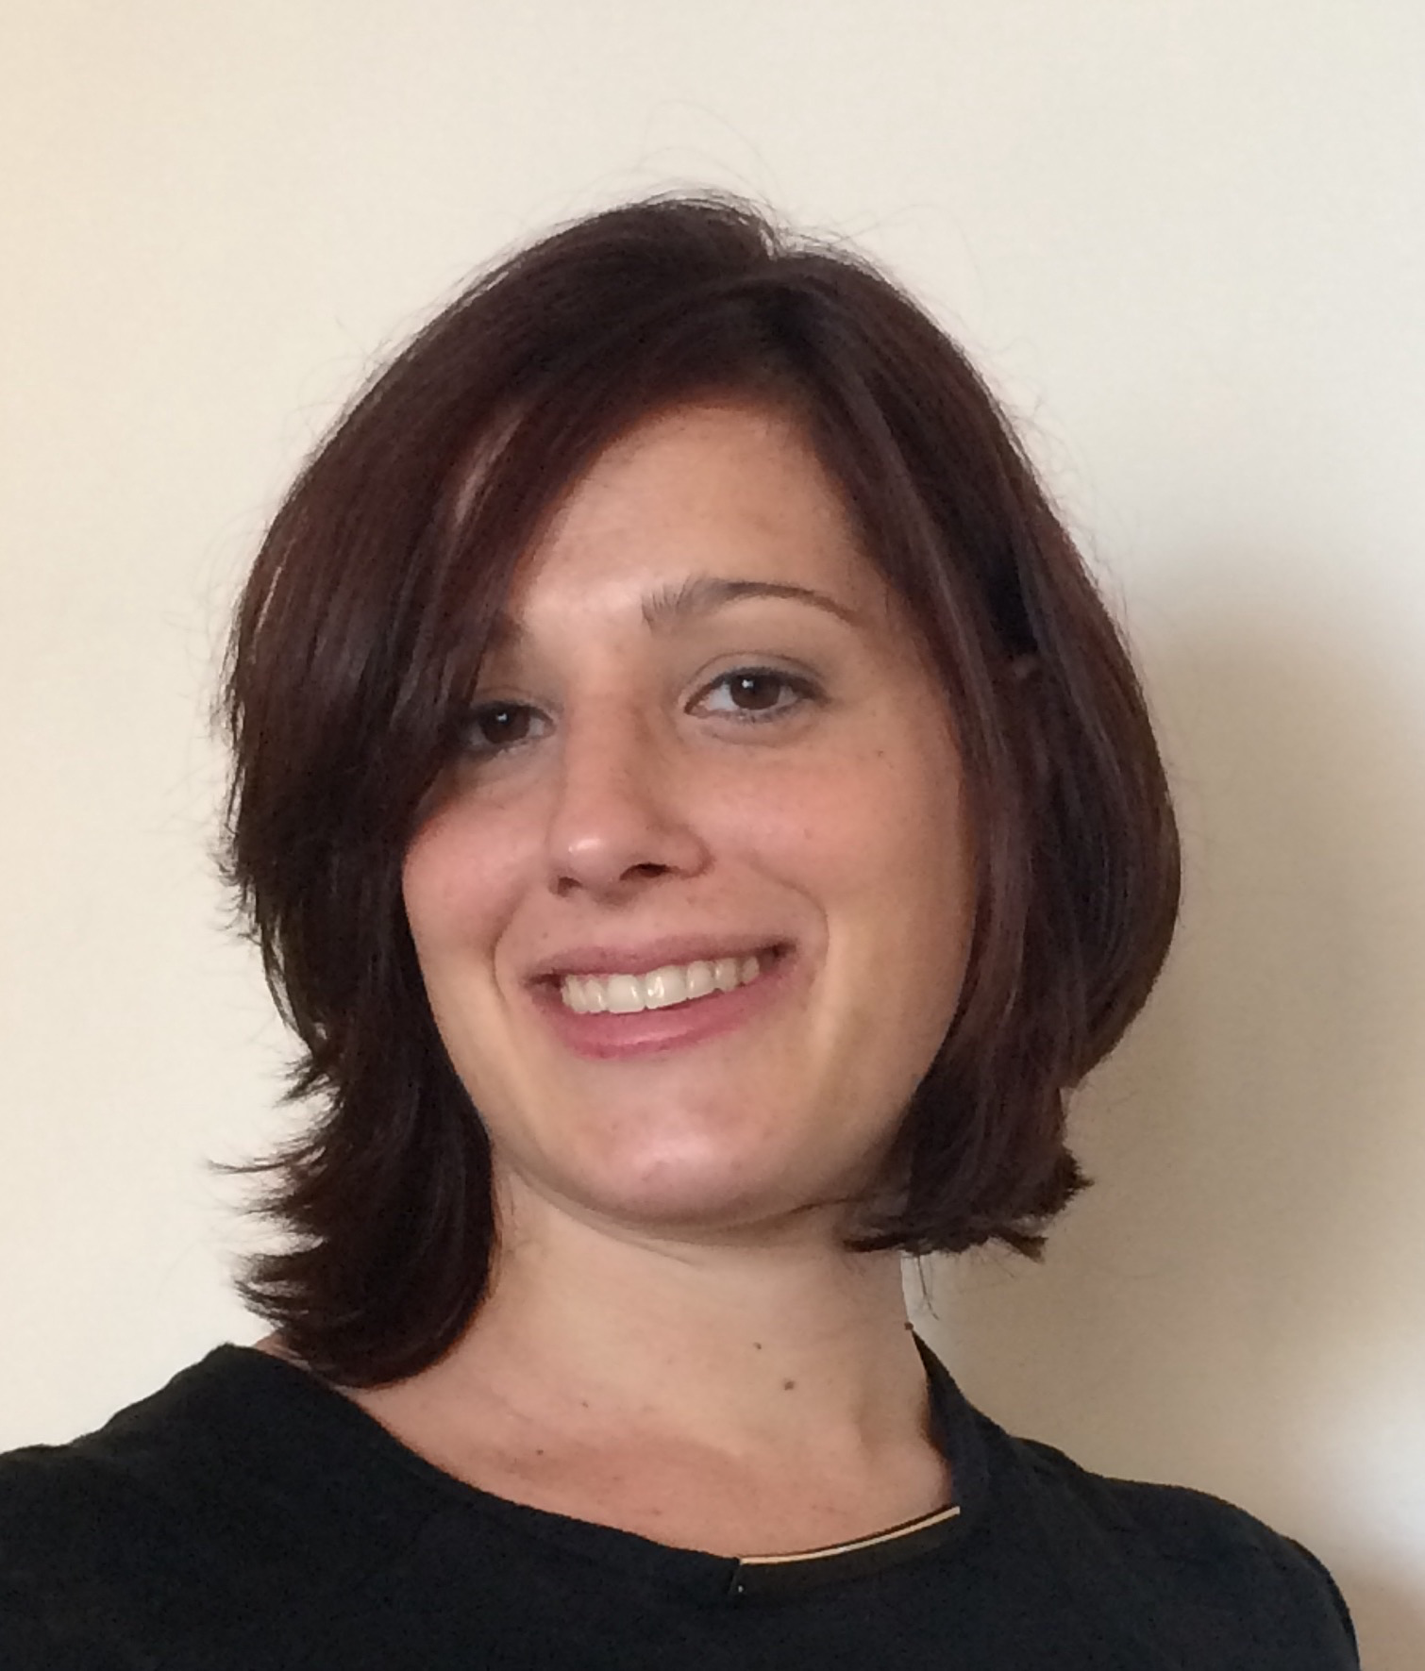I am a board certified Child, Adolescent, and Adult Psychiatrist working in private practice on the Upper East Side of Manhattan. In addition to treating general psychiatric disorders, I specialize in treating children with chronic medical conditions; particularly type 1 diabetes. My interests in working with the pediatric population started very early. I was diagnosed with type 1 diabetes at the age of 6 years. Living with a chronic medical condition has taught me about the intimate connection between the mind and body and the power of one to influence the other.

I have a bachelors degree in computational biology from Cornell University and attended medical school at the Medical School for International Health at Ben Gurion University in Israel. Following completion of my medical studies I received a masters degree in public health from Mount Sinai School of Medicine, with focus on health promotion and disease prevention, particularly in the area of type 1 diabetes. I completed both adult psychiatry residency and child and adolescent psychiatry fellowship at the Hofstra Northwell School of Medicine (formerly North Shore- LIJ).  In every stage of my training, I sought to deepen my understanding of the mind-body connection, and develop skills to help children maintain a balance between the two.

My individualized multifaceted approach to treatment includes a combination of psychopharmacology, various psychotherapy techniques, extensive work with and support for parents, coordination with schools and other treating physicians, as well as lifestyle modifications (relaxation techniques, sleep, nutrition, and exercise). I strongly believe that optimizing one’s physical health requires optimum mental health and vice versa. Additionally, I have completed training in Trauma Focused-Cognitive Behavioral Therapy, a model that can be used for children who have suffered medical trauma and those with chronic illness.

I look forward to meeting with you and welcome any discussion topics that you may have,



Daphna Shiffeldrim, MD, MPH