Dear Friends and Family,
We are incredibly honored to announce that our family has been selected to be the featured Fund A Cure Family at the Breakthrough T1D Gala on March 6, 2027.
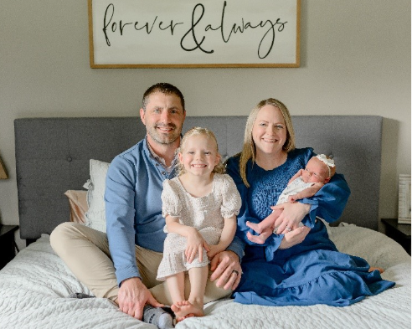
Our lives were forever changed just over two years ago on September 11, 2024. Kalla was just 3 years old and so excited to start her first school experience. After spending the last week of summer enjoying swimming, boating and family time up north, Kalla returned home for the start of preschool. She was just 3 days into her preschool journey when we noticed some abnormally excessive thirst and frequent urination. Despite still having her spunky personality and loads of energy, we sensed something must be off. After a day at preschool for Kalla and a day at work for mom and dad, we headed to urgent care at 8pm on the night of September 11th. We were fully expecting a UTI diagnosis and to be sent home with a short course of antibiotics to knock it.
The doctor came back with the results of the urine sample, which found zero bacteria, but a rather high level of glucose. Next came a finger poke and another, both with readings higher than the glucometer could measure…which meant a blood sugar greater than 600…then came the shocking diagnosis of Type 1 Diabetes. 3 Units of long-acting insulin were given at Urgent Care that evening and we were instructed to report to Children’s Hospital of Wisconsin at 7:30 the following morning.
We checked in the next morning, with little to no knowledge of Type 1 Diabetes and no idea what to expect for the days, weeks, months and years to come. Kalla’s blood was drawn to find an A1C of 10.1% and confirm her Type 1 Diabetes diagnosis. We spent the entire day at Children’s learning what was to become our ‘new normal’; finger pokes, counting carbs, insulin dosing through MDI and later a pump, high blood sugars, low blood sugars, A1C targets and more. We spent hours researching, reading and learning how to keep our 3 year old healthy and safe again.
The worst part as parents was knowing we could not take this away and watching our precious, sweet and spunky 3 year old, Kalla be defeated by this disease. The first days and months were incredibly difficult to swallow. Our life had felt like it turned upside-down. Kalla missed days of school, Kat took FMLA from work to try and manage daily injections at preschool and Nate spent hours learning about the disease and what this meant for our sweet girl.
I am happy to report, that 2 years later, things feel MUCH more manageable than they did on Day 1 and Kalla is no longer defeated by T1D but she defeats this disease daily to lead as normal a life as possible.
Over the past two years, Kalla has been an absolute warrior. She battles this disease every day with little to no complaints. She has not let T1D define her and will not let it keep her from chasing her dreams. Her bright and bubbly personality have not waivered. She is also very active – participating in swimming, gymnastics, soccer and golf and loves to be a princess! Of course there are inconveniences all along the way, with finger pokes, failed pump sites, sitting out of activities until her blood sugar rises, etc. - but she handles it with grace and doesn’t let it stop her. Her strength and resilience in the face of T1D inspires us every day, not to mention her already budding nutrition and math skills as she has to pay more attention to what she eats than most 5 year olds.
We are deeply grateful to Breakthrough T1D. Their funding is the driving force behind both today's diabetes technology and the pipeline's next generation of advancements. These advancements help Kalla to lead a more ‘normal’ life with T1D. Kalla wears a Dexcom CGM which allows us to monitor her blood sugar readings every 5 minutes - from an app on her phone, all our devices and many sugar pixels throughout our house to make sure we keep her safe. With this technology, the amount of times we have to do a manual finger poke have been greatly reduced. In addition, Kalla wears an Omnipod insulin pump which allows us to dose her insulin from a device rather than having to give her a shot every time she consumes carbs or has a high blood sugar. Breakthrough T1D is relentless in their mission, and we know their support will help fund a cure one day.
Beyond their incredible fundraising efforts, Breakthrough T1D has given our family something just as vital: the most amazing support group and friendships we could ever imagine. We always say, ‘it’s the best club that no one wanted to be a part of’. We are so thankful for the connections and support Breakthrough T1D has offered Kalla and our family through the years – it has made us feel much less alone in this journey.
One diagnosis changed our family’s life forever. Now, we are determined to help change the future of Type 1 Diabetes. Our family would be incredibly grateful if you would consider joining us for the Breakthrough T1D Gala on March 6th in Milwaukee. This will be an especially meaningful evening for us, as Kalla and our family will be featured at the Gala. We are honored to share our story and, more importantly, help raise funds for research that brings us closer to a cure.
Living with T1D means facing challenges every single day. While technology has come a long way, there is still so much work to be done. Our hope is that the next family facing a T1D diagnosis will have access to even better treatments, technology, and ultimately, a cure. We are committed to doing everything we can to make that future possible—and we will not stop until there is a cure.
There are many ways to show your support for Kalla and the T1D community. A gift to Fund A Cure is the most direct way to help power the research that changes stories like Kalla's — please consider joining us with whatever level of support is meaningful and comfortable for you:
- Make a Fund A Cure donation
- Host a table — personally or through your company as a sponsor
- Purchase a Gala ticket
- Donate an auction item

You can also support our efforts by sharing Kalla’s story with your employer or other local businesses seeking a meaningful way to fulfill their philanthropic goals. A simple introduction could help expand the impact of this important mission.
Every contribution makes a difference. Your tax-deductible support helps fund research that can change lives and bring us closer to a world without Type 1 Diabetes.
On behalf of our entire family, thank you for standing with Kalla, with us, and with every family affected by T1D. We are truly humbled to be part of this incredible mission and hope you will join us in the fight for a cure.

With love and gratitude,
The Newmeister Family

